**Requirement1:** User enters information into the input fields (Car Price, Down Payment, Interest rate, Number of months) and hits the calculate button to display the Payment details (Monthly payments, total amount paid, total interest paid) as well as displaying the calculated information in a table in case if the user wants to compare multiple payment options (**Refer to Figure1 for more details)**

|  |  |
| --- | --- |
| ../Desktop/Screen%20Shot%202018-03-02%20at%204.35.13%20PM.png | **../Desktop/Screen%20Shot%202018-03-02%20at%206.02.18%20PM.png** |

Figure : User enters info (before hitting calculate button). Figure1: After hitting the calculate button; Payment detail fields are updated and info is logged in tracker as well

**Page1**

**Requirement2:** If the user enters alpha numeric entries into any of the input fields (Car Price, Down Payment, Interest rate, Number of months) then the error must be caught and a message must be displayed below the input field **(Refer to Figures 2 &3 for more details).**

|  |  |  |  |
| --- | --- | --- | --- |
| **Input Field** | **Unacceptable entries** | **Display Message back to User** | **Acceptable Data entries** |
| Car Price | alphanumeric | Please enter a valid number | Integer & Double |
| Trade in/Down payment | alphanumeric | Please enter a valid number | Integer & Double |
| Interest Rate | alphanumeric | Please enter a valid number between 0-100 | Integer & Double |
| Months | alphanumeric | Please enter a valid number between 0-60 | Integer only |

|  |  |  |  |  |  |  |  |  |  |  |  |
| --- | --- | --- | --- | --- | --- | --- | --- | --- | --- | --- | --- |
| ../Desktop/Screen%20Shot%202018-03-02%20at%205.53.04%20PM.png  Figure :Handling alphanumeric inputs; displays 0.00 for payment detail fields and does not log the info into the tracker. | **Tracker**   |  |  |  |  |  | | --- | --- | --- | --- | --- | | **Searches** | **Car Price ($)** | **Interest Rate (%)** | **Months** | **Monthly Payment ($)** | |  |  |  |  |  |     **Page2** |
| ../Desktop/Screen%20Shot%202018-03-02%20at%205.56.19%20PM.png  Figure 3: Accepts integer and double user inputs; Press the Calculate Button and the Payment detail fields are updated and info is logged in tracker as well | **Tracker**   |  |  |  |  |  | | --- | --- | --- | --- | --- | | **Searches** | **Car Price ($)** | **Interest Rate (%)** | **Months** | **Monthly Payment ($)** | | **1** | **1000** | **4** | **12** | **85.15** | |

**Page3**

**Requirement3:** The following situation is a valid use case and needs to be implemented. There is a mistake in the calculation for monthly payments and needs to be fixed. Notice if you divide $100 by three the number should be $33.33. (Proof 33.33 x 3 = 99.99 and not 100). For cases like this the difference between the Car Price - Total amount paid = 100-99.99 = 0.01 must be added to the last monthly payment **(Refer to Figure 4 for more details).**

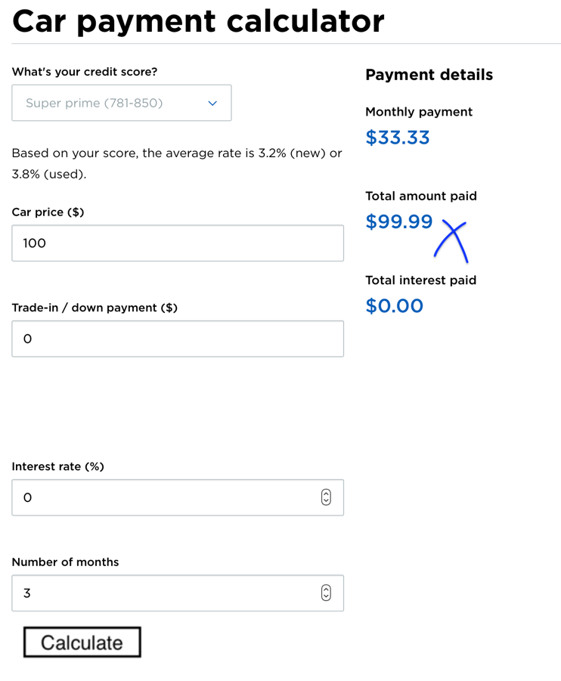 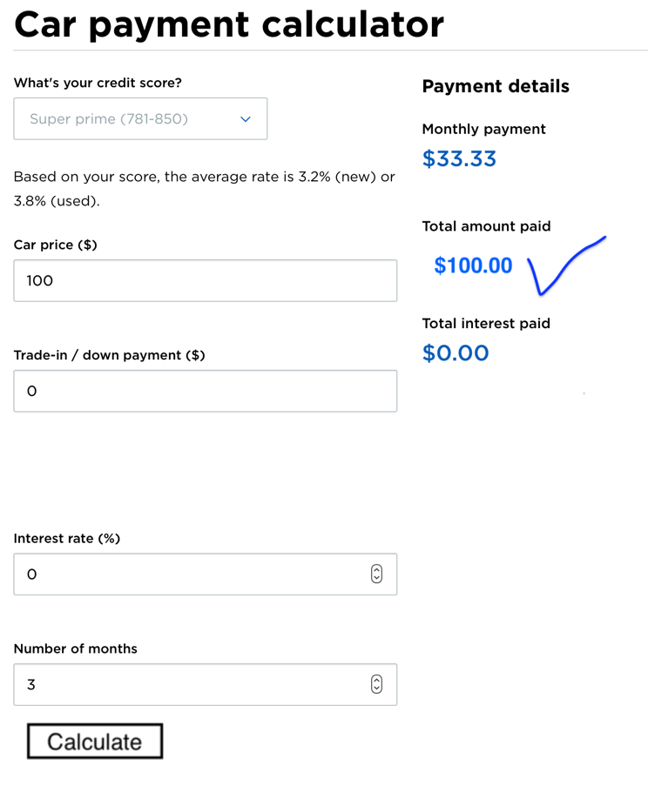

|  |  |
| --- | --- |
| Month | Payment |
| 1 | 33.33 |
| 2 | 33.33 |
| 3 | 33.33 + (100-99.99) = 33.34 |

|  |  |
| --- | --- |
| Month | Payment |
| 1 | 33.33 |
| 2 | 33.33 |
| 3 | 33.33 |

Figure : Don’t want this incorrect internal calculation Figure4: Need this correct internal calculation

**Page4**

**Requirement4:** If the Interest Rate field is empty then use default interest values for calculating the payment details output fields (Monthly Payments, Total amount paid, total interest paid). The default interest value is based on credit scores as shown in the table below **(Refer to Figure 5 for more details).**

**NOTE:** In Requirement1 the user manually enters the interest rate; requirement 4 uses a default interest rate if it’s the interest field is left unspecified by the user

|  |  |
| --- | --- |
| **Credit Score** | **Default Interest rate in case of empty interest field** |
| Super Prime (781-850), Prime (661-780), Nonprime (601-660) | 3.99 %, 4.99%, 6.99% |
| Subprime (501-600), Deep Subprime (300-500) | 11.99, 13.99 |

|  |  |  |  |  |  |  |  |  |  |  |  |
| --- | --- | --- | --- | --- | --- | --- | --- | --- | --- | --- | --- |
| ../Desktop/Screen%20Shot%202018-03-02%20at%206.33.15%20PM.png  Figure : Interest Rate is 3.99% due to credit score of super prime due to no user specification | **Tracker**   |  |  |  |  |  | | --- | --- | --- | --- | --- | | **Searches** | **Car Price ($)** | **Interest Rate (%)** | **Months** | **Monthly Payment ($)** | | **1** | **1000** | **3.99** | **12** | **83.33** | |

**Page5**

Requirement5: On the GUI; calculate the 4th variable given 3 variables. For example, if the user enters car price, interest rate and months; calculate monthly payments or if the user enters car price, interest rate and monthly payments then calculate months

$$Monthly Payment=\left(Car price-downpayment\right)*\left[\frac{interest rate{(1+interest rate)}^{months}}{{(1+interest rate)}^{months}-1}\right]$$

|  |  |  |  |
| --- | --- | --- | --- |
| **Car Price** | **Interest Rate** | **Months** | **Monthly Payment** |
| User input; Known | User input; Known | User input; Known | Calculate unknown; Use algebra |
| User input; Known | User input; Known | Calculate unknown; Use algebra | User input; Known |
| User input; Known | Calculate Unknown; use recursion | User input; Known | User input; Known |
| Calculate Unknown; use algebra | User input; Known | User input; Known | User input; Known |

a **Page6**